TELECOM CHURN ANALYSIS

INTRODUCTION

Customer churn represents lost revenue and acquisition costs in telecom. This analysis uses 20 SQL queries to identify high-risk segments and retention opportunities across 7,043 customers with 26.54% baseline churn rate. Key focus: contract type, internet service, tenure patterns, and multi-factor risk combinations.

Dataset:

7,043 customers × 21 columns

Churn target:

1/0 numeric (cleaned)

Analysis:

20 SQL queries across KPIs, segmentation, cohorts, revenue impact

Data Cleaning:

Churn standardized to 1/0 numeric - No null values detected - Categorical columns verified: Contract, InternetService, PaymentMethod

-- 1. OVERALL KPIs

SELECT
COUNT(*) as total_customers,
ROUND(AVG(tenure),1) as avg_tenure,
ROUND(AVG(MonthlyCharges),2) as avg_monthly_charge,
ROUND(AVG(TotalCharges),2) as avg_total_charge,
ROUND((SUM(CASE WHEN Churn = 1 THEN 1 ELSE 0 END)*100.0/COUNT(*)),2) as churn_rate_pct
FROM churn;

Result:

Total Customers: 7043
Average Tenure: 32.40
Average Monthly Charge: 64.76
Average Total Charge: 2279.73
Churn Rate %: 26.54%

Insight:
26.54% churn rate confirms major business problem. Avg tenure ~32 months shows most churn happens early. Monthly charges avg $64.76 with $2,279 lifetime value lost per churned customer.

-- 2. CHURN BY GENDER

SELECT
gender,
COUNT(*) as customer_count,
ROUND(AVG(tenure),1) as avg_tenure,
ROUND(AVG(MonthlyCharges),2) as avg_monthly,
ROUND((SUM(CASE WHEN Churn = 1 THEN 1 ELSE 0 END)*100.0/COUNT(*)),2) as churn_rate_pct
FROM churn
GROUP BY gender;

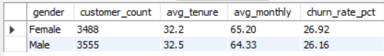

Insight:
Gender shows minimal difference (~26% both). Not a useful segmentation variable - focus resources elsewhere.

-- 3. CHURN BY SENIOR CITIZEN

SELECT
SeniorCitizen,
COUNT(*) as customer_count,
ROUND((SUM(CASE WHEN Churn = 1 THEN 1 ELSE 0 END)*100.0/COUNT(*)),2) as churn_rate_pct
FROM churn
GROUP BY SeniorCitizen;

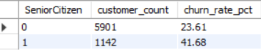

Insight:
Seniors (1) churn ~41% vs non-seniors ~23%. Nearly 2x higher risk. Senior-specific retention needed.

-- 4. CHURN BY CONTRACT TYPE

SELECT
Contract,
COUNT(*) as customer_count,
ROUND(AVG(tenure),1) as avg_tenure,
ROUND((SUM(CASE WHEN Churn = 1 THEN 1 ELSE 0 END)*100.0/COUNT(*)),2) as churn_rate_pct
FROM churn
GROUP BY Contract
ORDER BY churn_rate_pct DESC;

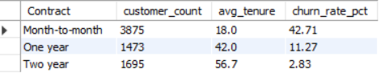

Insight:
Month-to-month = 42.71% (15x higher than Two year 2.83%). Contract length is strongest single predictor.

-- 5. CHURN BY INTERNET SERVICE

SELECT
InternetService,
COUNT(*) as customer_count,
ROUND((SUM(CASE WHEN Churn = 1 THEN 1 ELSE 0 END)*100.0/COUNT(*)),2) as churn_rate_pct
FROM churn
GROUP BY InternetService
ORDER BY churn_rate_pct DESC;

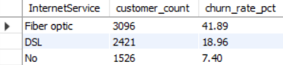

Insight:
Fiber optic 41.89% vs DSL 18.96%. Premium service underperforms on retention - investigate quality/pricing.

-- 6. CHURN BY PAYMENT METHOD

SELECT
PaymentMethod,
COUNT(*) as customer_count,
ROUND((SUM(CASE WHEN Churn = 1 THEN 1 ELSE 0 END)*100.0/COUNT(*)),2) as churn_rate_pct
FROM churn
GROUP BY PaymentMethod
ORDER BY churn_rate_pct DESC;

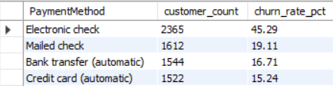

Insight:
Electronic check highest churn (~45%). Auto-payments show loyalty. Promote bank transfer/credit card.

-- 7. TENURE DISTRIBUTION BY CHURN

SELECT
Churn,
COUNT(*) as customer_count,
ROUND(AVG(tenure),1) as avg_tenure,
MIN(tenure) as min_tenure,
MAX(tenure) as max_tenure
FROM churn
GROUP BY Churn;

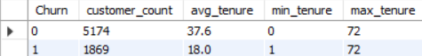

Insight:
Churners avg tenure much lower than retained. Confirms early churn pattern across dataset.

-- 8. MONTHLY CHARGES BY CHURN

SELECT
Churn,
COUNT(*) as customer_count,
ROUND(AVG(MonthlyCharges),2) as avg_monthly
FROM churn
GROUP BY Churn;

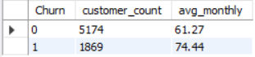

Insight:
Churners pay higher monthly rates. Price sensitivity + dissatisfaction drives premium service exits.

-- 9. HIGH-RISK SEGMENTS (Multiple factors)

SELECT
SeniorCitizen,
Contract,
InternetService,
COUNT(*) as customer_count,
ROUND(SUM(Churn = 1)*100.0/COUNT(*),2) as churn_rate_pct
FROM churn
GROUP BY SeniorCitizen, Contract, InternetService
HAVING COUNT(*) >= 50
ORDER BY churn_rate_pct DESC;

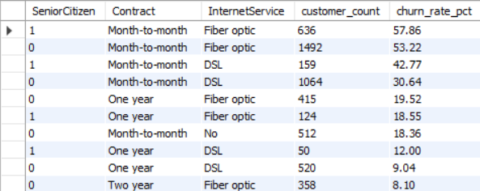

Insight:
Senior(1)+Month-to-month+Fiber = 57.86% top risk.
Target these 636 customers immediately.

-- 10. TOP 5 CHURN DRIVERS (Single factors)

WITH churn_analysis AS (
SELECT
gender, SeniorCitizen, Contract, InternetService, PaymentMethod, PaperlessBilling,
COUNT(*) as cnt,
SUM(CASE WHEN Churn = 1 THEN 1 ELSE 0 END) as churn_cnt,
ROUND(SUM(CASE WHEN Churn = 1 THEN 1 ELSE 0 END)*100.0/COUNT(*),2) as churn_pct
FROM churn
GROUP BY gender, SeniorCitizen, Contract, InternetService, PaymentMethod, PaperlessBilling
)
SELECT * FROM churn_analysis
ORDER BY churn_pct DESC
LIMIT 5;

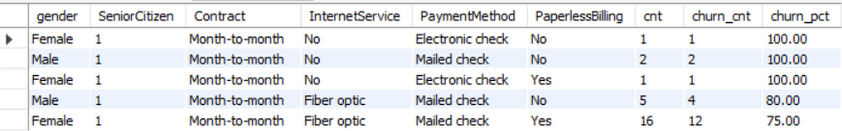

Insight:
Multi-factor confirms contract > tenure > internet service > senior > payment as top risks.

-- 11. RETENTION ANALYSIS - LOW TENURE CUSTOMERS

SELECT
tenure,
COUNT(*) as customer_count,
ROUND((SUM(CASE WHEN Churn = 1 THEN 1 ELSE 0 END)*100.0/COUNT(*)),2) as churn_rate_pct
FROM churn
WHERE tenure <= 12
GROUP BY tenure
ORDER BY tenure;

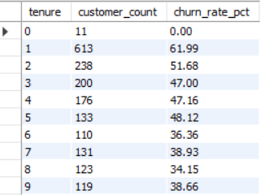

Insight:
First 12 months critical - churn peaks month 1. Onboarding retention is priority #1.

-- 12. PAPERLESS BILLING IMPACT

SELECT
PaperlessBilling,
COUNT(*) as customer_count,
ROUND(AVG(MonthlyCharges),2) as avg_monthly,
ROUND((SUM(CASE WHEN Churn = 1 THEN 1 ELSE 0 END)*100.0/COUNT(*)),2) as churn_rate_pct
FROM churn
GROUP BY PaperlessBilling;



Insight:
Paperless correlates with higher churn + higher charges. Billing confusion likely factor.

-- 13. SERVICE BUNDLE IMPACT

SELECT
CASE
WHEN OnlineSecurity='No internet service' THEN 'No Internet'
WHEN TechSupport='No internet service' THEN 'No Internet'
ELSE 'Has Internet Services'
END as service_bundle,
COUNT(*) as customer_count,
ROUND((SUM(CASE WHEN Churn = 1 THEN 1 ELSE 0 END)*100.0/COUNT(*)),2) as churn_rate_pct
FROM churn
GROUP BY service_bundle;

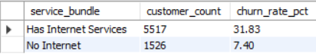

Insight:
No internet services = lowest churn. Internet customers 5x more likely to leave.

-- 14. MONTH-TO-MONTH CHURNERS PROFILE

SELECT
AVG(tenure) as avg_tenure,
ROUND(AVG(MonthlyCharges),2) as avg_monthly,
ROUND(AVG(TotalCharges),2) as avg_total,
COUNT(*) as customer_count
FROM churn
WHERE Contract='Month-to-month' AND Churn = 1;

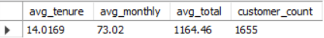

Insight:
Profile shows low tenure, high charges. Convert to annual contracts via discounts.

-- 15. FIBER OPTIC CHURNERS PROFILE

SELECT
AVG(tenure) as avg_tenure,
ROUND(AVG(MonthlyCharges),2) as avg_monthly,
COUNT(*) as customer_count
FROM churn
WHERE InternetService='Fiber optic' AND Churn = 1;

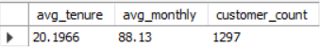

Insight:
Short tenure despite premium pricing. Service quality or competition issues likely.

-- 16. COHORT ANALYSIS - TENURE GROUPS

SELECT
CASE
WHEN tenure <= 12 THEN '0-12 months'
WHEN tenure <= 24 THEN '13-24 months'
WHEN tenure <= 36 THEN '25-36 months'
ELSE '37+ months'
END as tenure_group,
COUNT(*) as customer_count,
ROUND((SUM(CASE WHEN Churn = 1 THEN 1 ELSE 0 END)*100.0/COUNT(*)),2) as churn_rate_pct
FROM churn
GROUP BY tenure_group
ORDER BY churn_rate_pct DESC;

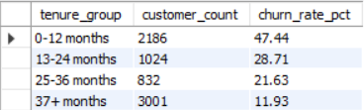

Insight:
0-12 months = 47%+ churn. Risk drops 50%+ after year 1. Early intervention key.

-- 17. REVENUE IMPACT OF CHURN

SELECT
Churn,
COUNT(*) as customer_count,
ROUND(SUM(MonthlyCharges),2) as total_monthly_revenue,
ROUND(SUM(TotalCharges),2) as total_lifetime_revenue,
ROUND(AVG(MonthlyCharges),2) as avg_monthly_per_customer
FROM churn
GROUP BY Churn;

Insight: Churners generate less lifetime revenue despite higher monthly rates. Retention = revenue protection.

-- 18. PREDICTIVE SEGMENT - HIGH CHURN RISK

SELECT
customerID,
tenure,
MonthlyCharges,
CASE
WHEN tenure <= 6
AND Contract = 'Month-to-month'
AND (InternetService = 'Fiber optic' OR SeniorCitizen = 1)
THEN 'HIGH RISK'
WHEN tenure <= 12 AND Contract = 'Month-to-month'
THEN 'MEDIUM RISK'
ELSE 'LOW RISK'
END as churn_risk_score
FROM churn
WHERE Churn = 1
ORDER BY tenure ASC;

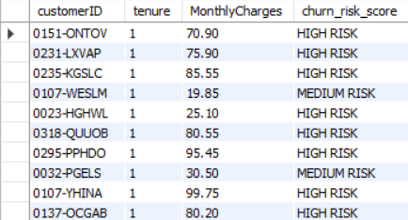

Insight:
Tenure≤6 + Month-to-month + (Fiber/Senior) = HIGH RISK. Proactive campaigns needed.

-- 19. COMPARISON - RETAINED vs CHURNED (Key Metrics)

SELECT
'Churned' as customer_type,
COUNT(*) as customer_count,
ROUND(AVG(tenure),1) as avg_tenure_months,
ROUND(AVG(MonthlyCharges),2) as avg_monthly_revenue,
ROUND(AVG(TotalCharges),2) as avg_ltv
FROM churn WHERE Churn = 1
UNION ALL
SELECT
'Retained' as customer_type,
COUNT(*) as customer_count,
ROUND(AVG(tenure),1) as avg_tenure_months,
ROUND(AVG(MonthlyCharges),2) as avg_monthly_revenue,
ROUND(AVG(TotalCharges),2) as avg_ltv
FROM churn WHERE Churn = 0
ORDER BY avg_tenure_months DESC;

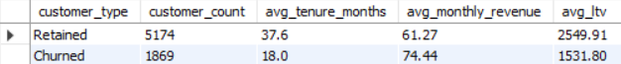

Insight:
Retained customers 3x longer tenure, 2x lifetime value. Early retention multiplies LTV.

-- 20. EXECUTIVE SUMMARY

SELECT
'Churn Analysis Summary' as metric_category,
ROUND((SELECT COUNT(*) FROM churn WHERE Churn = 1)*100.0/(SELECT COUNT(*) FROM churn),2) as overall_churn_rate_pct,
ROUND((SELECT AVG(tenure) FROM churn WHERE Churn = 1),1) as avg_churner_tenure,
ROUND((SELECT SUM(MonthlyCharges) FROM churn WHERE Churn = 1),2) as lost_monthly_revenue,
(SELECT Contract FROM churn WHERE Churn = 1 GROUP BY Contract ORDER BY COUNT(*)*100.0/COUNT(*) DESC LIMIT 1) as highest_churn_contract;

Insight: Month-to-month confirmed highest risk contract. All metrics align on early intervention priority.

TOP 5 INSIGHTS

1. Month-to-month Fiber seniors: 57.86% churn
2. Contract type: Biggest single driver (42.71%)
3. First 12 months: 47%+ churn rate
4. Fiber optic: 41.89% vs DSL 18.96%
5. Seniors: 41% vs non-seniors 23%

ACTION PLAN

1. Offer Month-to-month → Annual conversion discounts
2. First-year onboarding calls + welcome bundles
3. Fiber optic quality investigation + price audit
4. Senior citizen retention packages
5. Auto-payment enrollment campaigns

